New Life and Dream Building
Report on the Diversified Job Matching and Cooperative Education Programs Implemented by the Correctional Facilities

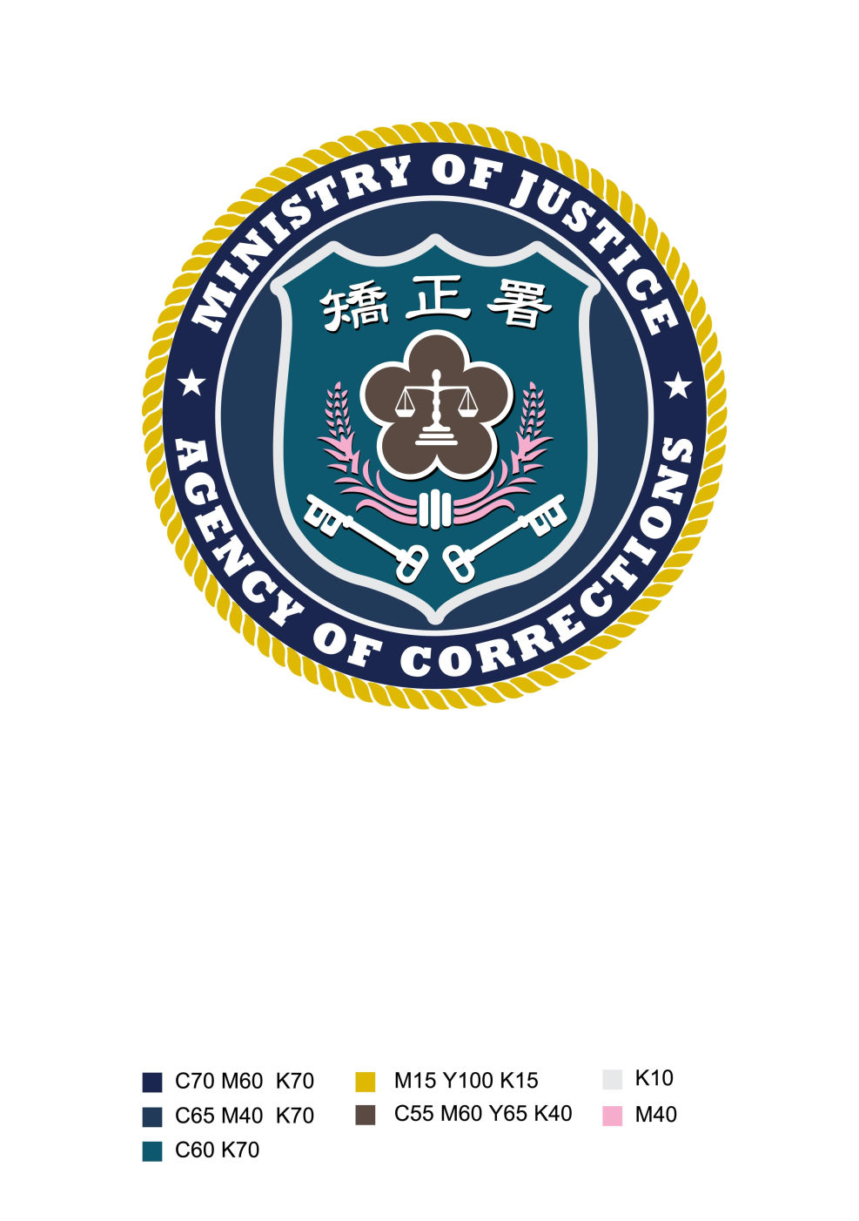

Agency of Corrections , Ministry of Justice
July 5th , 2013
Table of content
- Background ……………………………………………………………………………1
- Policy Implementation………………………………………………………………1
- Implementation Progress and Achievements……………………………………5
- Follow-up Measures , Management , and Evaluation…………………………11
- Case Studies of Successful Projects………………………………………………12
- News Reports…………………………………………………………………………14

New Life and Dream Building –Report on the Diversified Job Matching and Cooperative Education Programs Implemented by the Correctional Facilities

I. Background
Sensing the imbalance in the human resource supply and demand of the job market of the recent years, the Minister of Justice traveled to cities and villages and held forums with the industrial sector and understood the difficulty of the industrial and business sectors to find workers for their production demands. On the other hand, the correctional facilities of the nation incarcerate over 65,000 inmates that are ultimately bound for release and return to a life in the society. Hence, if it would be possible to provide character education, life education, and career ethics education to inmates and arrange the job matching with local enterprises and manufacturers or provide the cooperative education program that would enable inmates to receive work skill training and acquire a chance for a new life and build a realistic dream, it would also see to the reduction of the nation’s recidivism and unemployment rates and at the same time, provide a solution to the human resource shortage in the nation’s job market.

In light of which, the Agency of Corrections of the Justice Ministry formulated the “New Life and Dream Building – A Diversified Job Matching Program for Correctional Facility Inmates” on October 16, 2012 to establish a concrete manifestation of the public service spirit of the Justice Ministry and, through the implementation of the program, enable a consolidated integration of government resources, business sector demands, and the re-adaptation to society program for ex-convicts. The program is aimed to reduce recidivism rate and foster a more harmonious society, and make the public feel the Ministry’s cognizance of public sentiments and concern for the society, and at the same time enhance the public’s awareness of and confidence on government policies.

II. Policy Implementation
In the 1243rd MOJ internal affairs bulletin, the Minister instructed the respective correctional facilities to meet with enterprises and manufacturers and formulate a cooperative education program proposal before October 31, 2012. Correctional facilities were urged to take a proactive role in finding “livelihoods” for their inmates. Subsequently, the Minister held discussion meetings with the correctional facilities to understand the existing conditions of the respective facilities and to join the front line negotiation with enterprises and manufacturers, thereby alleviating the concerns and doubts of enterprises and manufacturers in hiring rehabilitated ex-convicts. On November 19, 2012, the correctional facilities were asked to formulate an implementation plan for the “New Life and Dream Building –A Diversified Job Matching Program for Correctional Facility Inmates” through which the program can be continuously implemented in the future. Moreover, the Ministry of Justice also held the following meetings on the subject matter:

- On October 8, 2012, Changhua Prison held a discussion forum which was attended by 29 representatives from the Cyuansing Industrial Park, Changhua Coastal Industrial Park, Fanyuan Industrial Park, Kuan-Lien Industrial Park, neighboring industrial parks, enterprises and manufacturers and heads of correctional facilities in the central Taiwan region. The forum enabled the industrial entrepreneurs to understand the rehabilitation and skill training results of the prison facilities. First, Changhua Prison presented a mini concert performed by its Meishan Bamboo Orchestra and Kuwu Percussion Group. Moreover, a peek into the operations of the lantern and buckwheat noodle workshops was provided. Next, a forum discussion was conducted on the issues of “providing job vacancies of local enterprises and manufacturers” and “inviting fine enterprises and manufacturers to join the inmate cooperative education program”. Both sides were able to fully convey their intents and ideas during the exchange of ideas. In the forum, the Minister of Justice announced that U-theater Performing Arts Group (U Theater) is helping the Changhua Prison organize its drum and dance performing group, and at present, two released rehabilitated ex-convict have become members of the U Theater group, one of which has become a mainstay of the group. Furthermore, the lanterns produced from the correctional facility workshops successfully won the Annual Lantern King Award of the Taiwan Lantern Festival. The meticulous delicacy of the workmanship and affordable prices of the lanterns have earned the good reviews and purchases of the public. Hence, if business enterprises are willing to uphold a sense of corporate responsibility and provide assistances, we can look forward to a drop in the rate of recidivism and enhancement of the peace and order of the society.
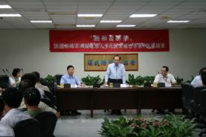


The Minister of Justice chaired the Job Matching and Cooperative Education Program with the Changhua area business sector.

- In an effort to understand the progress that the respective correctional facilities have made in their diversified job matching plans for inmates, the Minister of Justice proceeded to Taichung Prison and presided at the Discussion Forum on the “Joint Briefing of Diversified Job Matching and Cooperative Education Program” held on November 27, 2012. The directors of the eight correctional facilities in the central Taiwan region presented a report of the implementation progress. During the forum, the Minister of Justice obtained a brief of the implementation procedure and progress of the job matching plans from the correctional facility directors and was impressed by the dedication and proactive stance of the correctional facilities. He also stated that “not only did the correctional facilities prevent the emergence of craftsmanship gaps in traditional craft industries passed on through generations, but also fostered the continued innovation of the crafts to bring these traditional industrial skills to a new height. Moreover, those who were given second chances through the program were not only the ex-convicts but also the correctional officers who gained a new perception of their job. Correctional facilities have gone beyond a place for the restriction of freedom and punishment of criminal offenders, but also a place where convicts gain a new life education, character education, and skill training. Recently, frequent news articles on the job matching program of the correctional facilities have been reported. Incentive measures provided to participating enterprises and manufacturers came in form of gifts of exemplary arts and crafts works of prison inmates awarded in formal commendation rites, an expression of the ministry’s respect and gratitude to the significant contributions of the enterprises and manufacturers. The ministry also hoped that these incentives would spur other enterprises and manufacturers to participate in this program.”
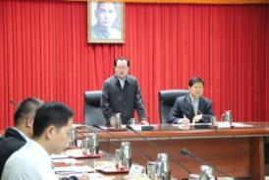


The Minister of Justice chaired the forum on the “Diversified Job Matching and Cooperative Education Program” implemented by the correctional facilities in central Taiwan.

3. Concerned with the progress that the correctional facilities in Hualien and Taitung have made in their respective diversified job matching plans, the Minister of Justice personally attended the joint progress report session of the nine correctional facilities in the Hualien area held on December 5, 2012; reports were presented by Ziqiang Minimum-Security Prison, Hualien Detention House, Taitung Prison, Taitung Rehabilitation Center, Taiyuan Skill Training Institute, Yanwan Training Institute, Dongcheng Skill Training Station, and Green Island Prison, and the following instructions were given by minister: (1) On the matter of short-term job matching, since the entrepreneur would not be able to understand the personal character of an inmate, a period of cooperative education and long-term observation of the inmate’s performance shall be necessary to help the entrepreneur feel secure with the inmate’s employment. (2) Character and life education of inmates should be strengthened to ensure that entrepreneurs would not be disappointed with their decisions. (3) The program requires long-term and far-sighted planning. The correctional facilities should dutifully execute their responsibilities in the screening of inmates for the program and should continue providing follow-up counseling. (4) Widespread assimilation of the local rehabilitation and protection associations, employment service centers, and local town and village administration offices (representatives) to join the program for the alleviation of the human resource shortage problems of localities.



The correctional facilities in Hualien and Taitung present a report of their Diversified Job Matching Program implementation progress to the Minister of Justice.

4. To foster the future employment of prison inmates and urge entrepreneurs to hire rehabilitated ex-convicts, the Minister of Justice presided over a “Diversified Job Matching and Cooperative Education Program” forum organized by the Hualien Prison on Dec. 25, 2012 for the correctional facilities and business entrepreneurs in Ilan, Hualien and Taitung. The forum was attended by the Director Chen Fu of the Ilan Lungte & Leizer Industrial Zone, Director Teng Kuo-Hsien of the Hualien Meilun Industrial Park, Director Chen Yao-Tseng of the Taitung Fongle Industrial Park, chief public prosecutors of Ilan, Hualien, and Taitung, directors of correctional facilities, chairpersons of inmate rehabilitation and protection associations, chairpersons and presidents of trade and industry associations, and representatives of 57 manufacturers. In his address, the Minister of Justice mentioned that in the recent local tours for a first-hand understanding of public sentiments, he discovered that many manufacturers were having difficulty hiring workers. Hence, through the forum discussions with manufacturers and entrepreneurs, he became aware of their needs and way of thinking. Under the program, the correctional facilities carefully select prison inmates manifesting good behavior for training and employment, thereby resolving the human resource shortages of manufacturers. The following issues were thus brought forward for forum discussion and study: (1) garnering the cooperation of local business sectors in providing employment opportunities; (2) invitation of fine manufacturing establishments to join the cooperative education program; (3) alleviation of the employers’ anxieties and concerns for hiring rehabilitated ex-convicts and fostering stronger hiring inclination among employers.
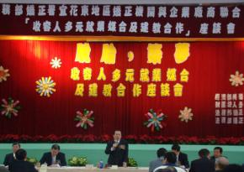


Minister of Justice presided over the joint forum attended by the correctional
facilities and business enterprises in Ilan, Hualian and Taitung.

III. Implementation Progress and Achievements
Making it a priority to help inmates due for release seek jobs, the correctional facilities started launching job matching activities for prison inmates from September 2012, such as, organizing the career fair for inmates, providing inmates with employment related information, and job matching for inmates. This allows them to make future plans for their life after their release from prison. The initial assessment showed that the campaign had achieved satisfactory accomplishments; according to national statistics data, as of May 31, 2012, the correctional facilities were able to accomplish the following: (1) Job matching service: a total of 946 manufacturers joined the campaign and offered 4,646 job vacancies. A total of 5,981 job matching applications were filed, and employment for 2,493 of which were successfully made (matching rate of 41.7%). (2) Cooperative education program: Skill training classes (acupressure foot massage, painting, rattan craft, interior electrical wiring installation, funeral service, etc.) and out-of-prison labor under the cooperative education program were provided to 35 participating correctional facilities by 52 participating manufacturers and business enterprises; a total of 1,064 inmates received training.

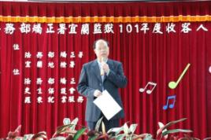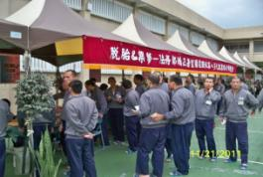
Northern Region – Career Fair Organized by Ilan Prison

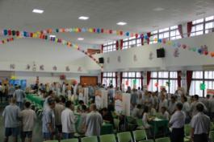
Central Region – Career Fair Organized by Yunlin Second Prison


Southern Region – Career Fair Organized by Kaohsiung Second Prison

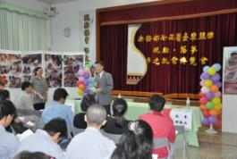
Eastern Region – Career Fair Organized by Taitung Prison

In addition to the job matching activities, in light of the rapidly changing job market skill requirements, the correctional facilities established the cooperative education program with manufacturers for the skill training of inmates. Training courses for work skills needed in the job market were introduced into correctional facilities to enable inmates to learn skills that cater to the society’s needs. A brief introduction of the programs implemented in some of the correctional facilities is provided in the following:
1. Kaohsiung Prison: Kaohsiung prison broke the rules with innovative action. Under its “Floating Duckweed Takes Root Project”, Kaohsiung Prison requested Bright City Environmental Services Co., Ltd. to hold skill training classes inside the prison facility. Kaohsiung Prison provided the needed space and selected inmates of sound mind and body and a strong inclination to find employment to attend the courses. Bright City Co. was requested to provide technical instruction to inmates who after their release from prison, may be placed into job positions in the parent company. In response to the huge janitorial service requirements of factories, offices, and public environments, Bright City Co. has developed a highly professional janitorial service technology. Moreover, it was willing to teach inmates the needed professional background and training, which indirectly opened employment opportunities to the inmates, thereby providing a job environment where rehabilitated inmates may be placed after rejoining the society. Through the cooperative agreement with Bright City Co. and Cheng Shiu University, the harmonious combination of academic, prison, and industrial resources fostered a trilateral cooperative education program involving the nation’s academic, industrial, and government sectors. In the course of their training and education, the hands-on skill training was provided to facilitate the selection of inmate trainees with the required capability and morality. The training equipped them with an expertise and enabled them to successfully join the janitorial service force after rejoining the society. It is hoped that the program would allow these inmates who underwent the reformative education and skill training programs of correctional facilities to truly turn over a new leaf.
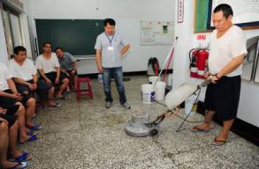


Cooperation Signing Ceremony of Kaohsiung Prison and Bright City Environmental Services Co., Ltd. | Hands-on training of janitorial service

2. Yunlin Second Prison: In enhancement of the job matching efficiency of the program, Yunlin Second Prison (YSP) established the Series of Diversified Job Matching Programs for Inmates under the following objectives: (1) To organize “bravely take a step forward and navigate a new course” campaign to foster the success of the employment counseling program. YSP worked together with the Taiwan After-Care Association in Yunlin and the Yunlin Potential Development and Psychotherapy Clinic in conducting the employment counseling program for prison inmates bound for release within the following three months. Through the group sessions and activities, pre-employment psychological exploration sessions were provided to strengthen the work ability and the self-recognition capacity of prison inmates soon to rejoin the society and to enhance their job knowledge. (2) to organize the “job matching program forums between inmates and employers”. Together with the Pei-Kang Employment Service Station and Touliu Employment Service Station under the umbrella of the Employment Services Center of Yunlin-Chiayi-Tainan Region, Bureau of Employment and Vocational Training, Council of Labor Affairs, the YSP organized discussion forums with business employers to alleviate the employers’ concerns on hiring rehabilitated ex-convicts and to strengthen their hiring inclination. The forum also enabled the employers to understand the accomplishments of the inmate treatment practices of the correctional facilities. (3) To organize the “Employment Orientation Seminars” for inmates who are bound for release or for parole within the following four months. An early announcement of the job vacancies offered by the employers participating in the career fair shall be made in these seminars. The guidance and analysis of the instructors increased the inmates’ understanding of the job market status quo and employment resources available and enabled them to select the right career. The forums increased the job matching success rate and improved the stability of their employment. (4) To organize “career fair for inmates”. The career fair is launched in cooperation with the Taiwan After-Care Association in Yunlin, Yunlin County Labor Department, Pei-Kang Employment Service Station and Touliu Employment Service Station under the umbrella of the Employment Services Center of Yunlin-Chiayi-Tainan Region, Formosa Plastics Group, and the manufacturers and associations of the neighboring industrial parks. Manufacturers and business employers were invited to provide employment counseling and job matching services inside the prison facility for inmates bound for release soon. The endeavor helped inmates establish the confidence to find employment and assisted inmates in formulating their career plans after their release. Thereby, after their release, they shall be able to successfully find employment and start a new life.
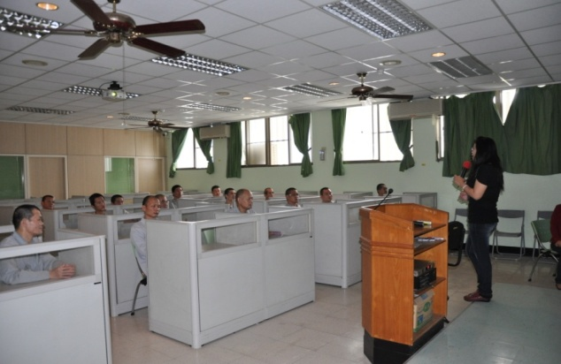
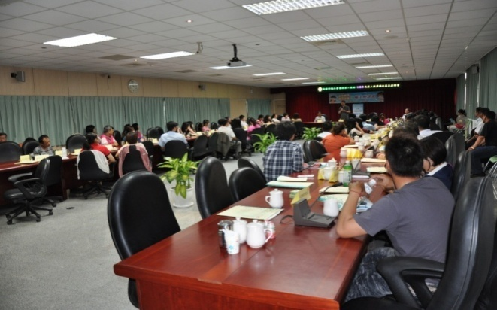

Inmate employment orientation seminar held at Yunlin Second Prison | Manufacturer orientation seminar at Yunlin Second Prison

3. Ziqiang Minimum Security Prison in Hualien: Although Hualien and Taitung are regarded as remote regions, the prison administration aggressively sought the cooperation of businesses and manufacturers having similar operations or services for the organization of cooperative education programs. Professional skill training was introduced to inmates through the different cooperative projects, thus making it possible for inmates to acquire skill mastery and enhance the quality of their work and performance. The specific implementations included the following: (1) Meat product processing training under the cooperative education program launched with Kuang-Feng Farmers Association: Inmates received actual work training and learned professional meat processing skills in the factory grounds; moreover, assistance of the Kuang-Feng Farmers Association was solicited in the job matching for rehabilitated inmates in meat cutting and processing job positions. (2) Cultivation of toxin-free peeled chili pepper under the cooperative education program with the Hualien Specialty Store located in Huagangshan: The specialty store assisted in providing cultivation technique instructions; moreover, the specialty store was requested to help introduce rehabilitated inmates to related toxin-free farming industries or encourage inmates to work with the store to cultivate peeled chili pepper for a living after their release.

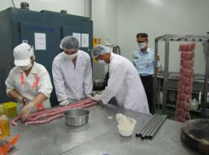
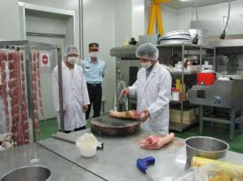

Hands-on training of meat processing techniques

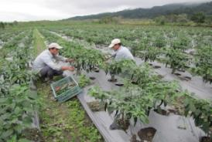
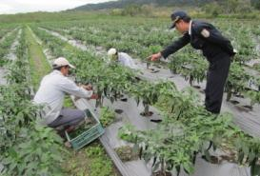

Cultivation of Toxin-free Peeled Chili Pepper under the Cooperative Education Program

4. Taichung Women’s Prison (TWP): Work training at ALD as an out-of-prison labor was provided to inmates. The job description was to attend to the warehouse management of the Wholesale Warehousing Division. In 1989, ALD established the first self-service professional hardware chain store in Taiwan. It developed a complete professional hardware management system consisting of two major parts, the “wholesale warehousing management” and the “retail point of sale (POS)”. The system provides automated stock shipment and replenishment operations, precise merchandise selection, price control through bulk procurement, and immediate replacement of slow-selling stock. Moreover, a high-performance computer operating system enhanced its timely and accurate distribution of products. On December 1, 2012, ALD offered two job vacancies to rehabilitated inmates, and thereafter, ALD had continued to hire workers from the minimum-security prison of the TWP. Thus, inmates who were willing to work in ALD after their release may first learn the ropes as a worker, and upon their release, may continue with their employment service.
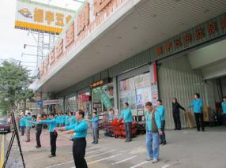
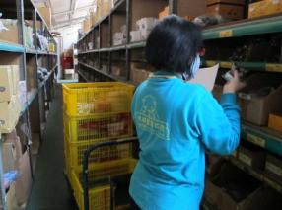

Trainees learn warehousing operations at ALD retail store

IV. Follow-up Measures, Management, and Evaluation
In the process of implementing the “New Life and Dream Building” project, the MOJ directed all its subordinate agencies to maintain regular contact with the regional employment service centers or employment service stations of the Bureau of Employment and Vocational Training, Council of Labor Affairs and the respective local branches of the Taiwan After-Care Association and hold intensified employment adaptation and growth group activities and employment orientation seminars for prison inmates and to organize a career fair around two to three times a year for inmates to sustain the effectiveness of the program.
As for the cooperative education program, MOJ has issued official instructions to the respective correctional facilities to establish skill training centers and to contact the vocational training centers of the Bureau of Employment and Vocational Training, Council of Labor Affairs for assistance and supervision in the selection and determination of facility equipment, teaching materials, and training courses, thereby ensuring their suitability to the job market needs and establishing a cooperation system for the faculty resource and course subjects of the vocational training classes. Furthermore, the MOJ invited enterprises and manufacturers for orientation seminars and an observation tour of the correctional education and skill training classes conducted within the correctional facilities. To date, quite a few correctional facilities and manufacturers have signed cooperative education agreements; for instance, the painting skill course of Taipei Prison, caregiver training course of Taichung Prison, funeral service training of Tainan Prison, welding class of Kaohsiung Second Prison, and food and beverage service class of Pingtung Prison. The classes had been effective in preparing inmates for employment after their release from prison.

To maintain a grasp of the career progress of ex-convicts after their release, effective 2013, the Agency of Corrections instructed the correctional facilities to submit a monthly report on state of affairs and successful job matching cases and to conduct telephone surveys to follow up the employment conditions of rehabilitated inmates after rejoining the society. The survey obtains an understanding of the actual work performance of the ex-convict and the underlying factors of their continued or concluded employment. Information shall serve as reference for the future post-incarceration employment counseling of prison inmates, thereby allowing inmates to acquire an early readiness for employment while still in prison or to find employment even before their release from prison and reducing chances of recidivism. This is the highest aspiration and objective of the crime prevention campaign of the MOJ.

V. Case Studies of Successful Projects
(1) A-kan’s Story
A-kan committed the crime of attempted homicide, a crime of passion, and was sentenced to an imprisonment term of five years. He had never thought that the price he had to pay for hitting a person would be so high. Regret and misery had thrown his life into its darkest pit. Now incarcerated in jail, A-kan learned the art of drumbeating through a chance encounter. Under the tutelage of the U Theater master, he became a member of the Changhua Prison drum and dance performing group, through which he gradually recovered his self-confidence and acquired a sense of achievement in his accomplishments. He also enjoyed the opportunity in performing in many a concert show.

In light of good behavior in prison, the U Theater troupe decided to recruit him as part of their permanent cast of performers after his release from prison. After a period of stringent training and appearing in hundreds of performances, A-kan not only found a new lease on life but also a new line of hope. A development worth special mention is that in order to make up for his sense of guilt, A-kan expressed an intent to compensate the injured party with his limited income. Through the assistance of Changhua Prison and some concerned individuals, a meeting between A-kan and his injured party was arranged and was personally attended by the Minister of Justice. Seeing the sincerity of A-kan’s remorse, the injured party decided to forgive him. This was the first time that a correctional facility was able to see to justice administered through an amicable agreement between the parties. His story had been documented in a short video footage to show the society A-kan’s intent and determination to reform his life.

(2) Gang Leader Turned Lantern King
In the lantern competition of 2012 Taiwan Lantern Festival held in Lu-Kang of Changhua, the 2.5 meter tall “Rabbit in Armor” lantern entry of former Yinlin Prison inmate won the title of Lantern King for its creator. The lantern designer Lan Yung-Chi was a former Haiti Hall Leader of the Four Seas Gang. Convicted for the crimes of robbery and controlling guns, he was sentenced to an imprisonment term of seven years and four months and a penalty fine of NT$100,000. Shortly after his imprisonment, his ailing father passed away. Remorseful, he set his heart to a life of reformation and to turn on a new leaf.
While serving his sentence, he took a lantern craftsmanship class under the tutelage of Maste Huang Wen-Chuan, the Chairperson of the Chinese Artistic Lantern Association. He found his transcendental inspiration in the course of learning the lantern making, and thereafter, began to reevaluate the significance of his life and had a grasp of the value of life. After his release from prison, he sought employment at the Chinese Artistic Lantern Association, where he now holds the position of director of Chuan-Tsai Lantern Creation Atelier. And the mean-eyed, violent gang leader that he once was had now become a gentle and patient lantern craft master.
(3) Painting Life with Colors
Writer Tsai Yung-Fu advocated that one has to swing back to zero before one could swing the other way to victory; he believed that going back to zero was another way of learning. After one has returned to zero, one could start all over again and boldly face a whole new world. This was the turning point of his life. He spent fourteen years of his life in jail due to drug abuse; however, his family had firmly stood by his side all through the years. Hence, after his release from prison, he gained enlightenment and struggled to start a new life. This determination was the seed that germinated into a vibrant, fulfilling life.

In 1999, Mr. Tsai Yung-Fu and his father founded the Shin Tai Paint Engineering Co., Ltd. Through honesty, loyalty to commitment, and untiring dedication, their business flourishes and now produces an annual sales income of NT$800 million. Shin Tai Co. is now among the “good manufacturers” of the Formosa Plastics Group, and employs over a thousand employees, 400 of which are rehabilitated ex-convicts. Mr. Tsai once told the rehabilitated ex-convicts that they could always come to work for his company if they could not find a job; however, they should observe the rules of no fighting , troublemaking and no drugs.
As long as they could observe these two rules, they would never lose their livelihood. This successful entrepreneur has never forgotten to give back to society. He personally handled the painting skill training classes of inmates in correctional facilities, and shared his personal experiences with inmates, encouraging them that it is never too late to change for the better. Because after one has turned back to zero, then everything ahead of one is wiped clean, and one could paint the color that one wants to have.

VI. News Reports
(1) Changhua Prison
News Headline: “President Ma Addresses the Career Fair Held by Changhua Prison – Helping an Inmate is Saving a Home”
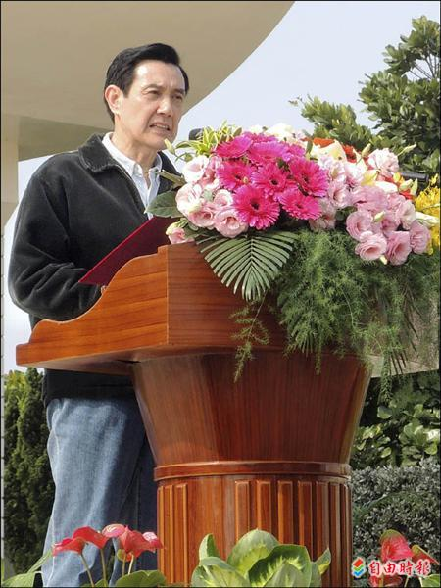
- Liberty Times
- 2013-3-17 by Liu Hsiao-Hsin at Erh-Lin
Pres. Ma Ying-Jeou accompanied by Minister of Justice Tseng Yung-Fu and Changhua County Commissioner Cho Po-Yuan visited the career fair held for inmates by the Changhua Prison yesterday morning. He expressed in his address that helping an inmate is also saving a home. Allowing inmates to successfully find employment after their release from prison could convert them into a positive force for the community.
Pres. Ma Ying-Jeou viewed the lantern handicraft works of the inmates and enjoyed the energetic drumbeating number of the Changhua Prison inmates, a number choreographed by U Theater Group. Later, he proceeded to the booth area and shook hands with the manufacturers who joined the program.
Pres. Ma Ying-Jeou stated that during his term as the Minister of Justice, Taiwan had over 200 correctional facilities. He believed that the government should extend a hand to help inmates released from prison to overcome job seeking difficulties in order to truly realize their return to community life, and at the same it would be able to encourage convicts in prison to learn some skills that would open future employment opportunities for them. For instance, in the recent Taiwan Lantern Festival event, exhibit viewers were able to see some artistic work handcrafted by prison inmates.
Pres. Ma Ying-Jeou also stressed that helping an inmate would be tantamount to rescuing a family and turn the negative fortunes of an inmate to a positive one. It would also be doing a good deed. Many inmates in incarceration are gearing themselves to find a new lease on life. A little push towards the right path would mean bolstering the positive forces in the community.
Yesterday, over fifty manufacturers joined the career fair organized by Changhua Prison, and over 400 job vacancies were made available to inmates. Majority of these jobs were in the field of care-giving services, janitorial services, sales representation, and electrical and plumbing works.

(2) Kaohsiung Prison
News Headline: “Under the Company of Family Members, 62 Inmates Found Jobs”
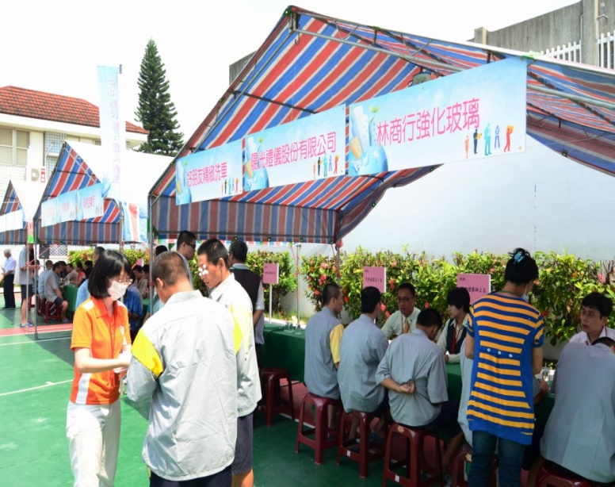
- United Daily News
- 2013-5-31 by Kao Pei-Te at Kaohsiung
29 Manufacturers offered 239 job positions in the career fair organized by Kaohsiung Prison. The job matching service provided inmates with a sense of belonging; some inmates decided to attempt to acquire professional licenses and some started planning their future livelihoods.
In the career fair organized by Kaohsiung Prison yesterday, the 29 participating manufacturers offered 239 job positions to the inmates. Moreover, prison authorities opened, for the first time, the day to inmate families, enabling family members to accompany inmates taking job interviews. By the end of the day, 62 inmates were able to avail of a good job, a precursor shining a bright light to their soon-to-come new life.
Prior to the opening of the career fair, Kaohsiung Prison first scheduled employment seminars and orientation session within its large auditorium. Prison warden Tai Shou-Nan was invited to address the crowd and to urge inmates to put past grudges and vendettas behind and be ready to face a future of freedom.

Footages of the vocational training accomplishments of inmates were shown in the seminar. In addition to the usual bread and pastry, oil paper umbrella, peanut candy making and computer repair and maintenance skills, the prison authorities also invited professional instructors to teach inmates how to construct a mobile toilet. Kaohsiung Prison also showed the latest result of the inmates’ research and development work, a snack item called seaweed flakes. The program had provided the inmates to master a skill while serving their sentences.
The 29 manufacturers invited to participate in the career fair offered 239 job positions ranging from electrical and plumbing technicians, drivers, janitors, chefs, operators, and service personnel. Families of 57 inmates who came to join them accompanied them during the interviews to bolster their chances of recruitment. By the end of the day, 62 inmates were able to find jobs.
Hsiao-Lee who is serving a two-year sentence for drug possession had never had any skill before; hence, it would be quite easy for him to return to his previous life. He was glad to join the employment training activities organized by the prison authorities. In the future, he hopes to find a farming or garden landscaping related work.
Hsiao-Kang who is serving a three-year-plus sentence for offenses against sexual autonomy expressed that participating in the job matching program gave him a sense of belonging. In the future he hopes to find a job in a restaurant or funeral parlor. So far he has acquired a Class C computer repair technician skill and is planning to take the test for a Class B license.
Kaohsiung Prison Warden Tai Shou-Nan stated that many inmates yearn to reform themselves. Family support is very important in this endeavor. This career fair was a breakthrough from the traditional setup since inmate families were invited to participate, and it is hoped to help inmates rebuild their homes.

